# Subsetting with .loc[]

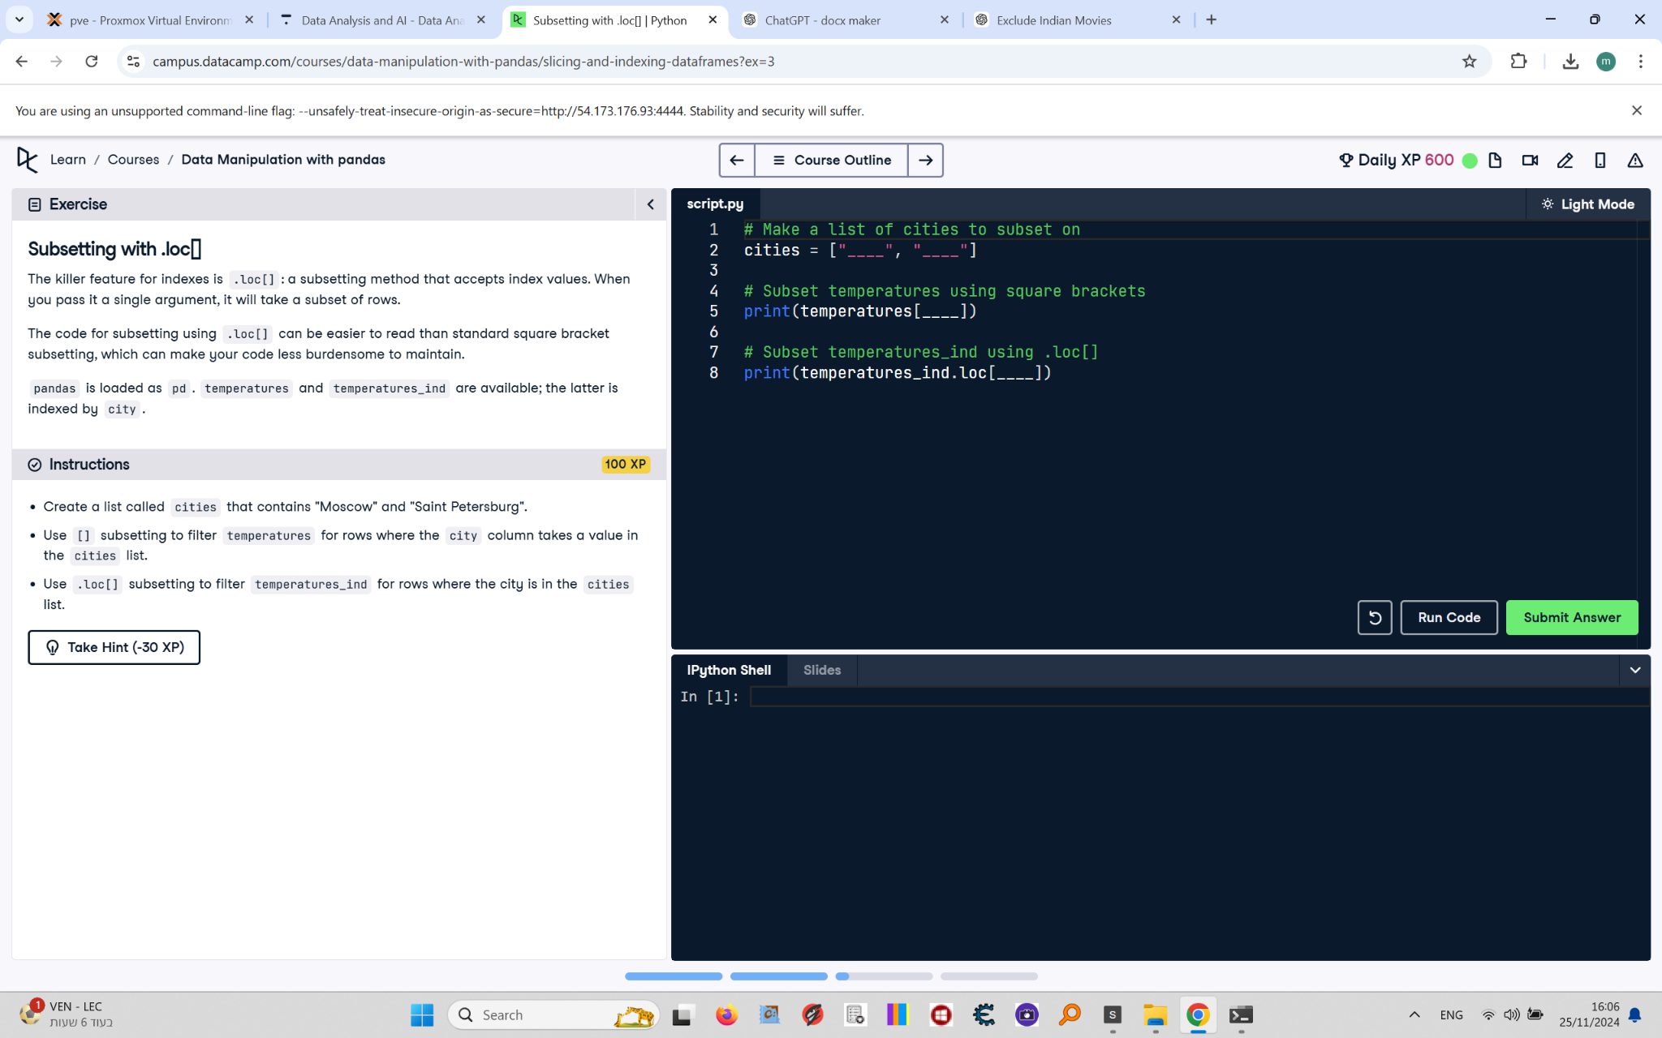

The killer feature for indexes is .loc[]: a subsetting method that accepts index values. When you pass it a single argument, it will take a subset of rows.  
  
The code for subsetting using .loc[] can be easier to read than standard square bracket subsetting, which can make your code less burdensome to maintain.  
  
pandas is loaded as pd. temperatures and temperatures_ind are available; the latter is indexed by city.

## Final Answer

# Make a list of cities to subset on  
cities = ["Moscow", "Saint Petersburg"]  
  
# Subset temperatures using square brackets  
print(temperatures[temperatures["city"].isin(cities)])  
  
# Subset temperatures_ind using .loc[]  
print(temperatures_ind.loc[cities])